Cp/Cv uputstvo za projektovanje

Sema se moze naci na linku:
https://tinyurl.com/222asnle

kao i na slici ispod:

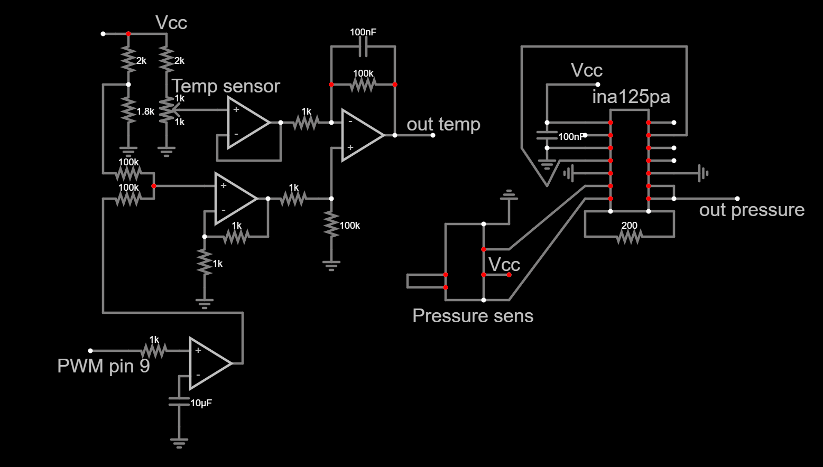
out temp se povezuje na pin broj A0,
out pressure se povezuje na pin broj A2.
Temp senzor: KTY82-210
Senzor pritiska: MPX2200AP

Arduino kod:

//Kod za Arduino UNO za merenje pritiska i temperature istovremeno, real time u python-u
#include <TimerOne.h>
int out_Val, out_pressure;
int duty = 500;
int pin = 9;
int analogReadMean(int pin = A0, double num_samp = 100.0){
long val = 0;
int ii = 0;
for (ii = 1;ii<num_samp;ii++){
val = val + analogRead(pin);
}
return val = val/num_samp;
}
void setup() {
// put your setup code here, to run once:
Timer1.initialize(1000); // 1 kHz
Serial.begin(9600);
out_Val = analogRead(A0);
while (out_Val > 410 || out_Val < 390) {
out_Val = analogRead(A0);
if (out_Val > 410) {
duty = duty + 1;
Timer1.pwm(pin, duty, 1000);
} else if (out_Val < 390) {
duty = duty - 1;
Timer1.pwm(pin, duty, 1000);
} else {}
int out_pressure = analogReadMean(A2,100.0);
out_pressure = out_pressure - 620;
Serial.print(out_pressure);
Serial.print(",");
Serial.println(out_Val);
delay(50);
}
}
void loop() {
//Merenje pritiska
int out_pressure = analogReadMean(A2,100.0);
out_pressure = out_pressure - 620;
Serial.print(out_pressure);
Serial.print(",");
//--------------------------------------------------
out_Val = analogRead(A0);
Serial.println(out_Val);
delay(50);
}

Koristi se Arduino Uno (CH340 u konkretnom slucaju)

